Community Event Nominated:
Event Name:
Organisation
Venue of Event: Date of Event:
Name of person(s) representing the event: 1.
2. 3.
Address:
Phone: Mobile:
Email:

Nominated by:
Name:
Organisation:
Address:
Phone: Mobile:
Email:

Referee: (other persons that may be contacted for further information about nominee)
Name:
Organisation:
Address:
Phone: Mobile:
Email:

Close of Nominations:
Nomination forms must be received by 4:15pm close of business Friday 1st December 2023 on behalf of the Shire of Brookton to the Brookton Community Resource Centre via one of the following methods:

Email: Kylie.Freeman@brookton.wa.gov.au
Hand Deliver: 89 Robinson Road Street, Brookton WA 6306

Please write below a short description (500 words or less)

the purpose of event and the scope of impact that it had on the Community.

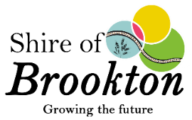
Community Event of the Year Award – Criteria & Eligibility

*Nominations are based on events held throughout the 2023 year, and the awards will be presented on Australia Day 2024.

- The quality of the event

- The Award is granted to the “event” and not to the organizing committee.

- The purpose of the event must be community focused and not staged for personal or private reward or financial benefit.

- An event cannot receive a second award in this category.

- The scope of impact the event or act has had on the local government area including the achievements and reasons for the nomination must be explained.

- The event’s lasting contribution to the community.

